Movie Database
Built using SQL, Python Streamlit Anthony Wang
An interactive Power BI dashboard that analyzes sales, customer details, and product details.
Achieved data cleansing and data transformation process for data extraction using SQL, dimension tables and fact tables from AdventureWorks data warehouse.

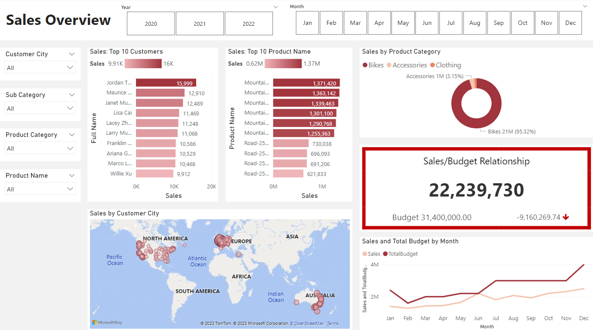
Sales Overview:

It is designed to provide a comprehensive summary of sales performance across various dimensions. The dashboard includes several key sections: Filters, Top 10 Customers by Sales, Top 10 Products by sales, Sales by product category, Sales/Budget relationship, Sales by customer city, and sales and total budget by month.
Filters utilizes Year, Month, Customer City, Sub Category, Product Category, and Product Name as criteria to narrow down search results. This helps users find specific information they need in a large database.
Sales Top 10 Customer and Sales Top 10 Product Names are both horizontal bar charts that list the top 10 results based on sales volume.
Sales/Budget Relationship shows the relationship and differences between sales in dolalrs and budget. It is an indication of performance; red border of the box represents underperformance and green represents good performance.
Sales by customer city is a map that visualize geographical distribution of sales, which means customer locations are marked across different continents.
Sales and Total Budget by Month is a line chart that tracks sales and budget trends over the months. The chart can demonstrate seasonal fluctuations in sales.

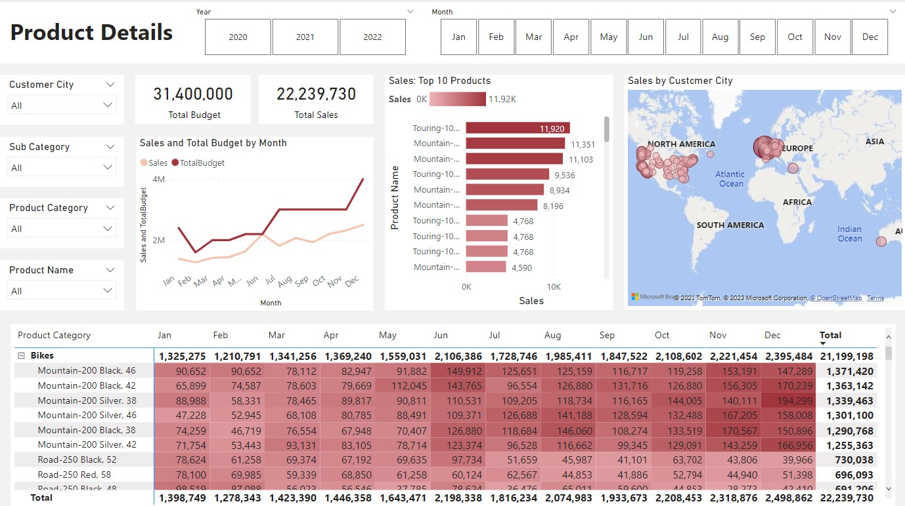
Product Details
The "Product Details" dashboard is designed to provide a comprehensive summary of product-specific sales performance across various dimensions. The dashboard includes several key sections similar to the sales overview dashboard.
The heat map table displays monthly sales figures for products within the selected category. This visual approach helps users quickly identify trends, seasonal patterns, and top-performing items based on the intensity of color

Dimension and Fact Table
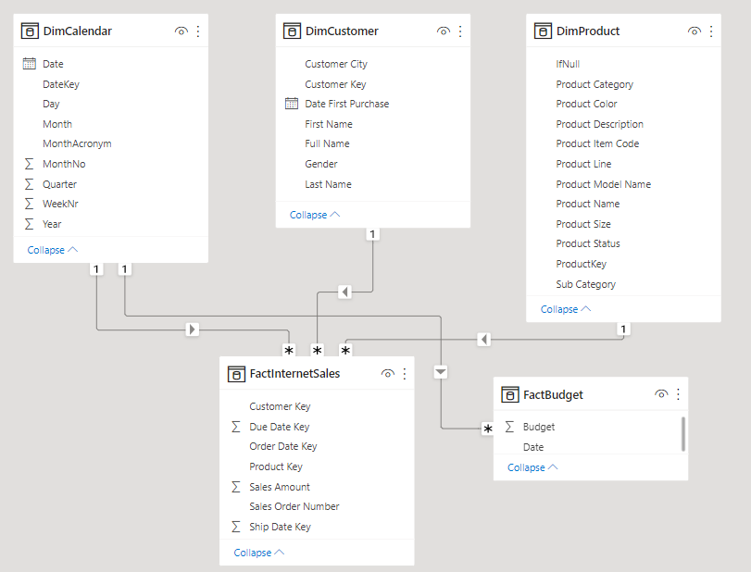
This is a model with dimension and fact table, which is a common structure in data warehousing and business intelligence for organizing and analyzing data.

Dimension tables store descriptive attributes that provide context for the facts in the fact table. Fact tables store quantitative data for analysis. Relationships in this model are mainly one to many.

